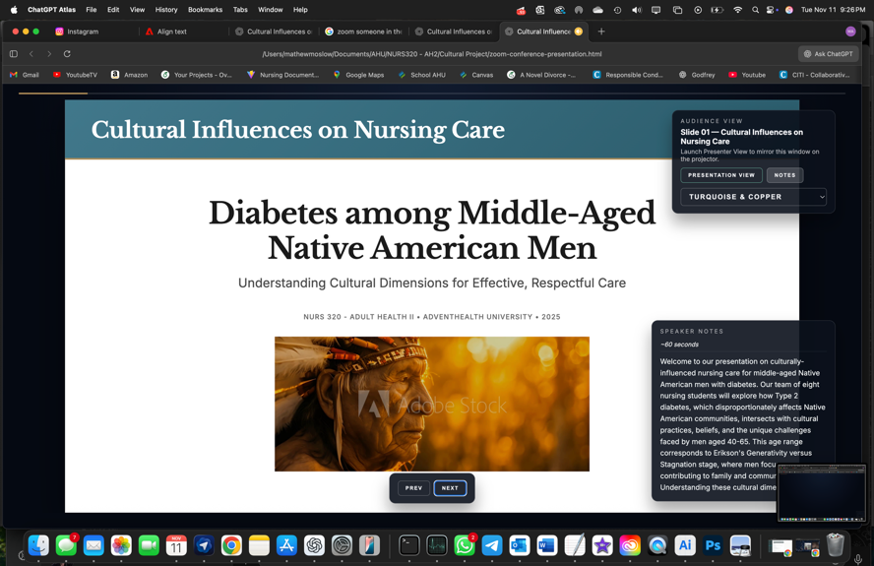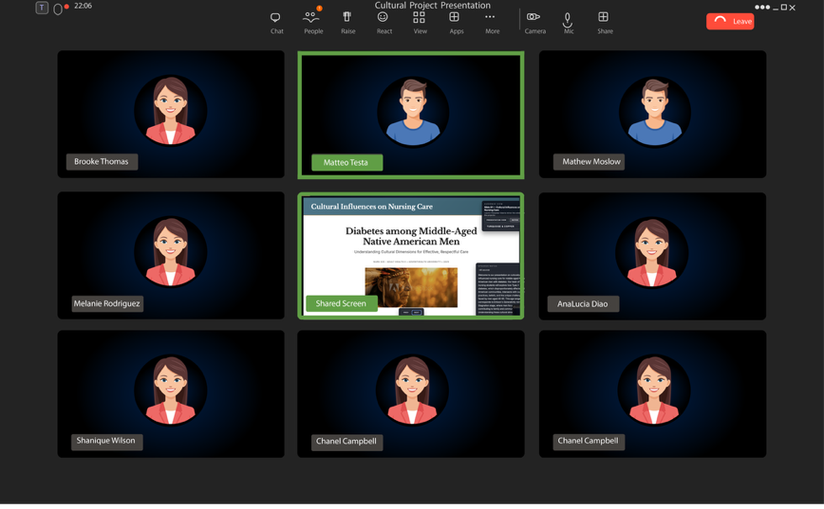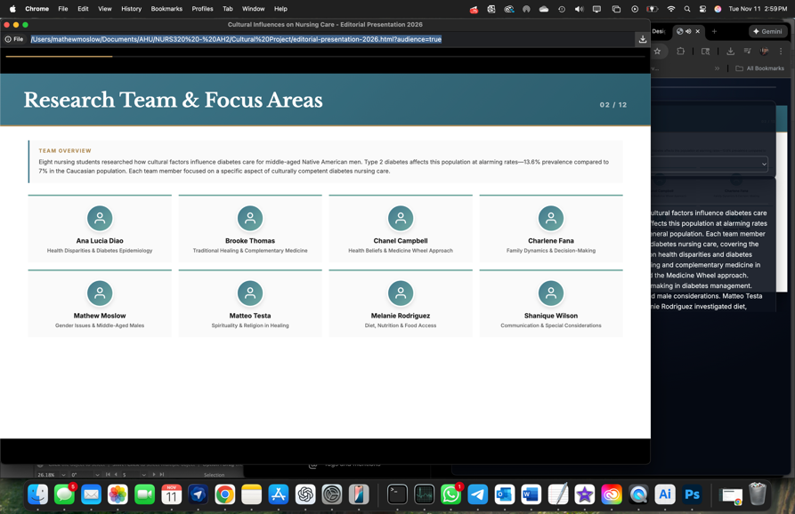
Audio cue: our team of 8 student nurses (persist until next audio begins)
Audio cue: Welcome to our presentation on…(persist until beginning of next audio)

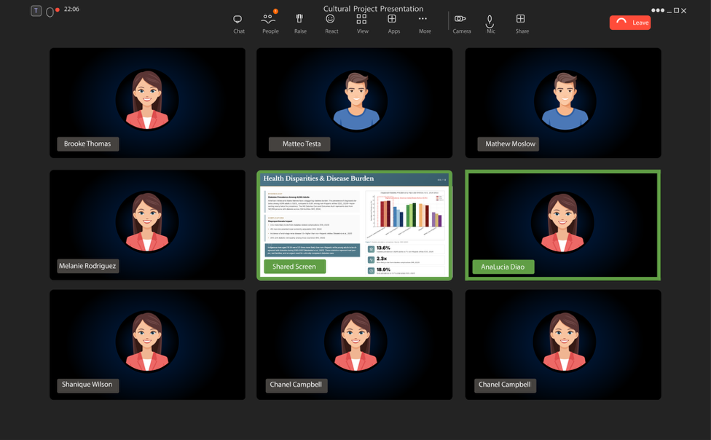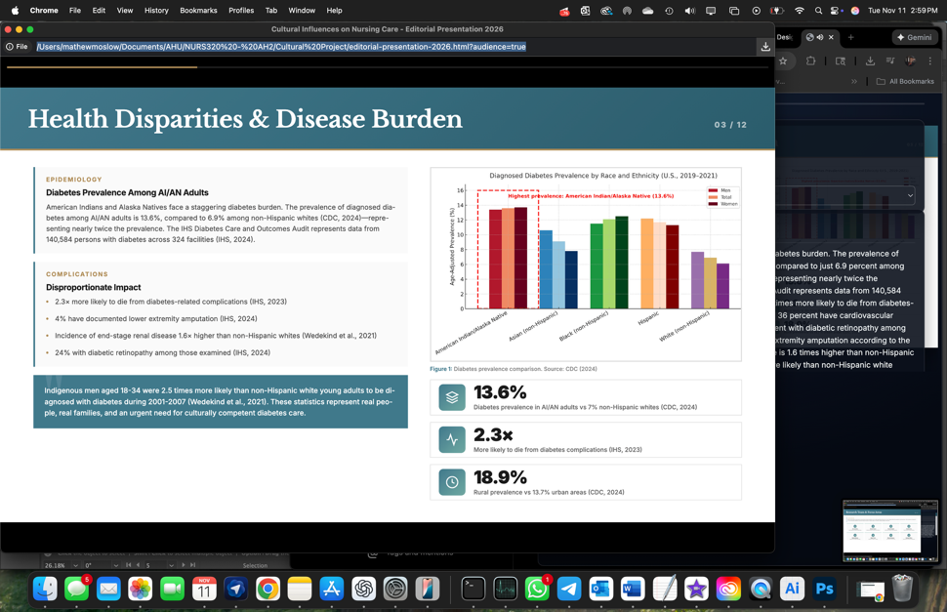
Cut to the slide and stay until next audio begins.
Audio cue: American Indians and Alaska Natives face a staggering diabetes burden. Persist 10-15 seconds)
Audio Cue: The diabetes epidemic in Native American communities did not happen by chance. (stay on screen 10-15 seconds)

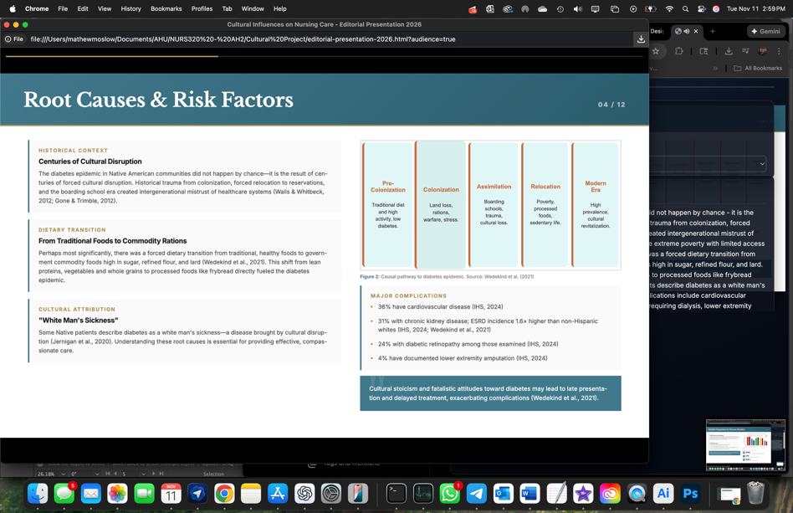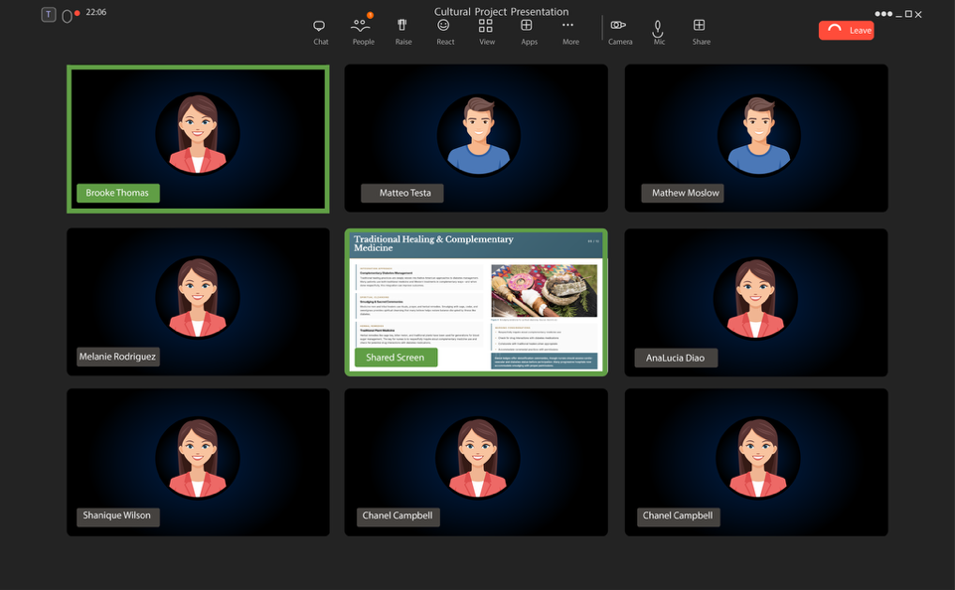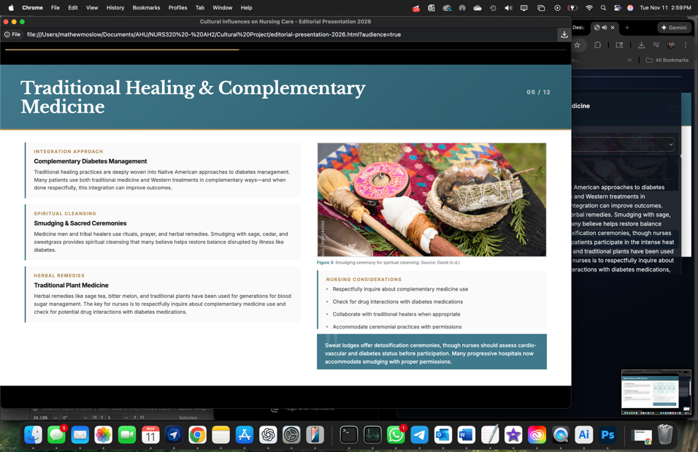
Remain on screen until the beginning of next audio
Audio cue: Traditional healing practices are deeply woven into Native American approaches to diabetes management. (persist 10-15 seconds)
Remain on screen until next audio begins

